Installation Process of Mobile Trading Application (IWIN)
Prerequisite for Application
1. Check the compatibility of Mobile Device from Arihant Website.
2. Enhanced GPRS should be activated on Device from respective Service provider
3. On 3G Network can also work.
4. Higher Black Berry Plan required
--- Internet Plan required for the service - 3G/Advance GPRS/Higher Black
Berry
We have tested on Blackberry/Nokia/Android/Samsung/LG device,

Step One:

Type below URL in your Mobile Browser

IWIN URL: http://www.arihantcapital.com/ -Click on Quick link—Click on Commodity Mobile Software.
Or
http://202.87.50.137:8282/iwin/setup/
Or
SMS from the mobile device where Client wish to install Software.
SMS to 56677 with subject- Arihant Mobile- he will get the link of software.

You will get the list of Directory
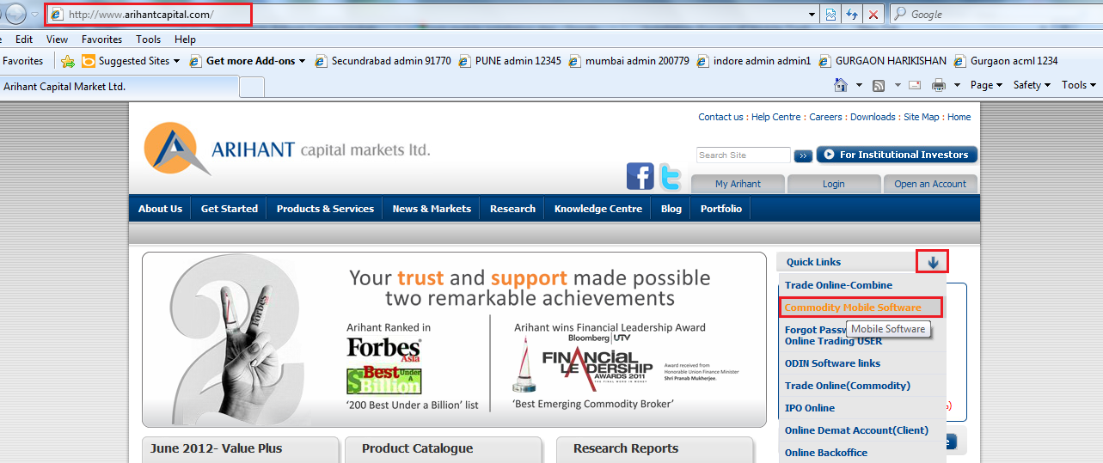

After clicking on Commodity Mobile Software – client will get below mention link will come.
As per client Mobile device inform him to download the software.
For Android mobile – please download software from Android Mobile
For Blackberry Non touch- download from Non touch
For Black Berry Normal- download from Blackberry.,
For other device- like Nokia,LG,Micromax, etc – download from other device.
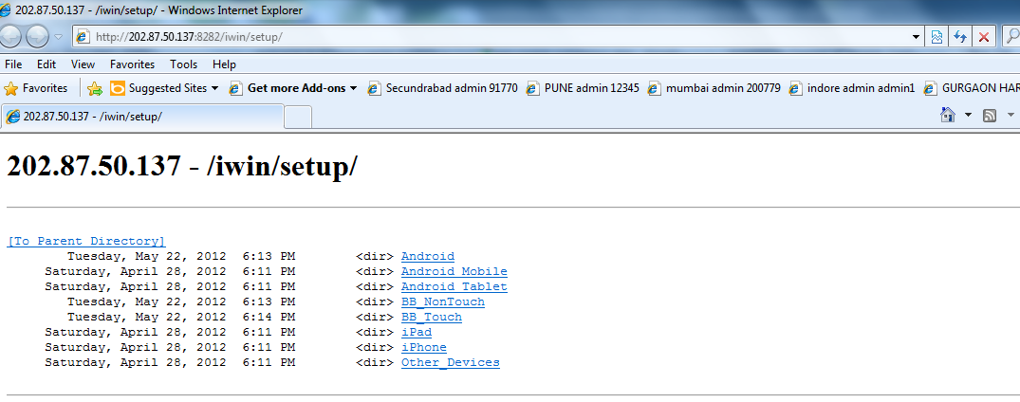
Step Two:
As per Mobile O.S. Download and install. Giving example for below files for Blackberry Devices.

For Non Touch Download .jad file as per Black Berry O.S.
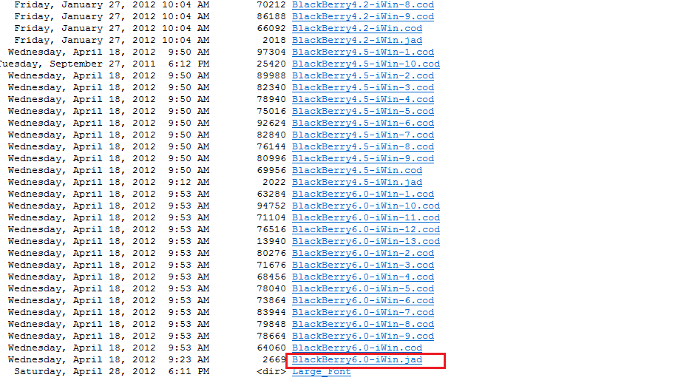

OR

Download and install below files for Other Blackberry Devices.
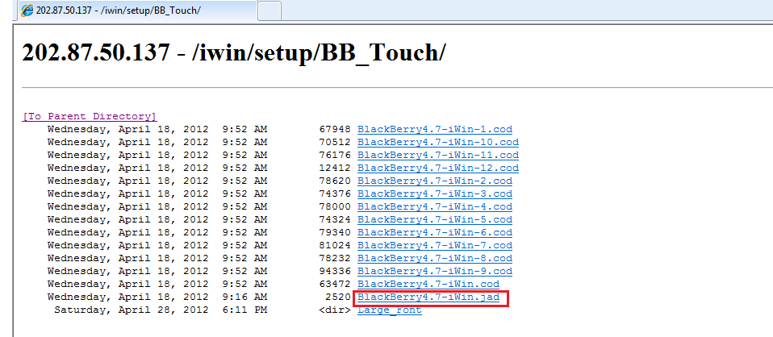

For other Mobile O.S. Click on Other_Devices
E.g. Nokia
Download .jad file
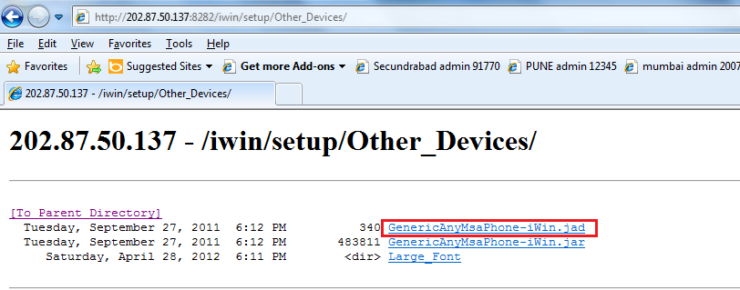
For Android Mobile O.S. Click on Android Mobile
E.g. Samsung
Download .apk file
Step Three:
After installation you will get IWIN icon on the Desktop OR in Downloads Option
Click on IWIN icon & it will ask for below URL and broker code
Broker URL: http://<ip>/<Dir>/Brokersettings.aspx then edit the URL and type there
http://202.87.50.137:8282/iwin/brokersettings.aspx
Broker Code: 12345
Then click on: Update settings
This will take time will ask for user name & password for login given by your Commodity Department..
Enter your USER ID & PASSWORD and Enjoy the Wireless Trading.
Note that- proper file should be downloaded as per Customer mobile devices.For Demo you can refer - http://arihantitrade.com/odin/odin/demo/iWin%20Demo%20for%20Mobile-%20Integrated.zip
Please contact us if you have any query or problem with the download or activation of the service.

After successful installation you will get following logo on your mobile device
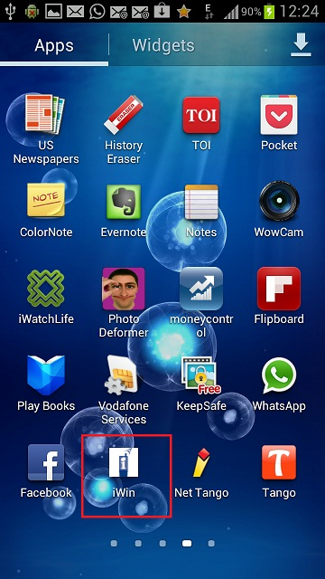
Open the application

It will ask for user id and password
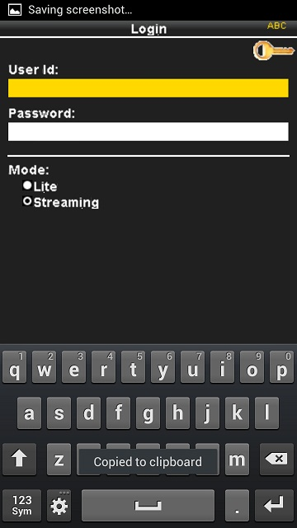
Kindly put your “IWIN” user id and password which is you got from us.
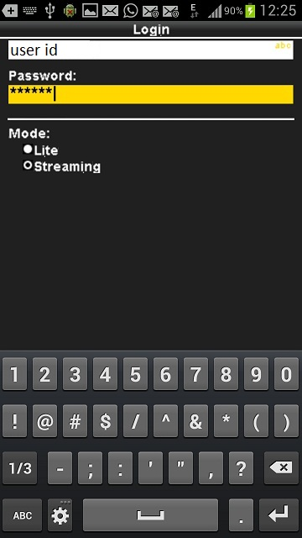

After putting user id and password press enter button of your mobile device.
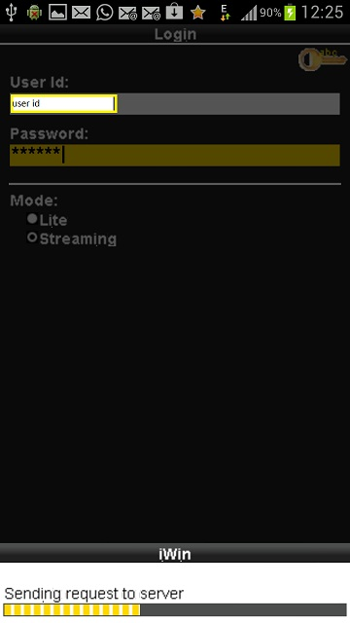
After successful login you will get menu like this
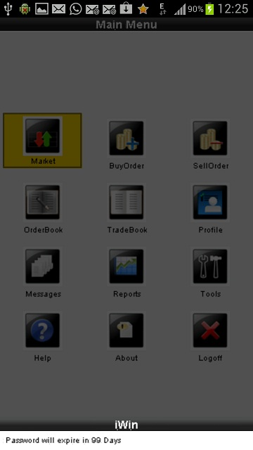

Now you create profile for market watch screen
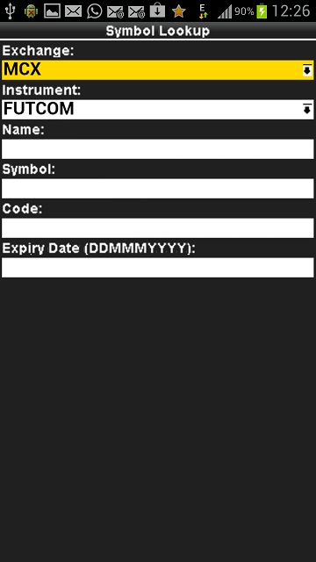
Choose the exchange and scrip and per you choice and add in to market watch profile
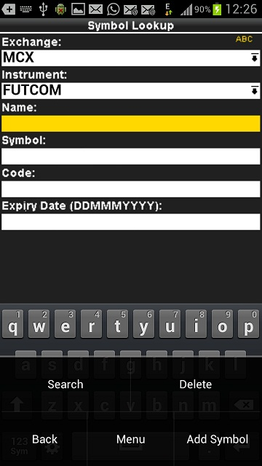

Just save and go back to market screen you can see your profile.
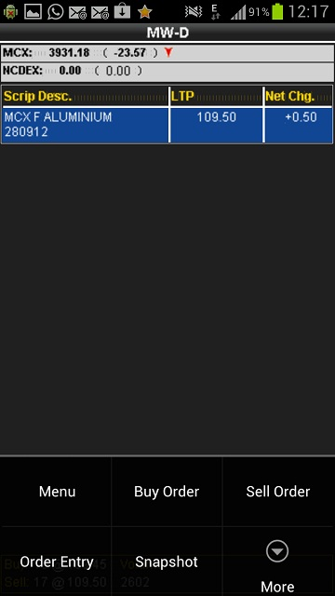
Press the menu button to see more option.
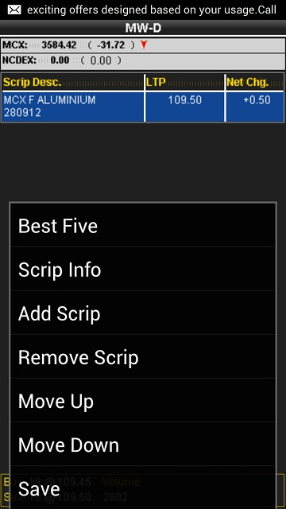

For disable broadcast timeout setting go to tools
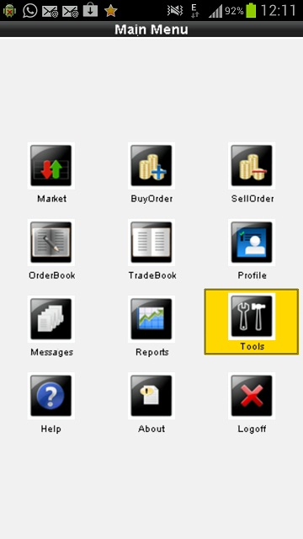
And choose user setting and choose broadcast stop time
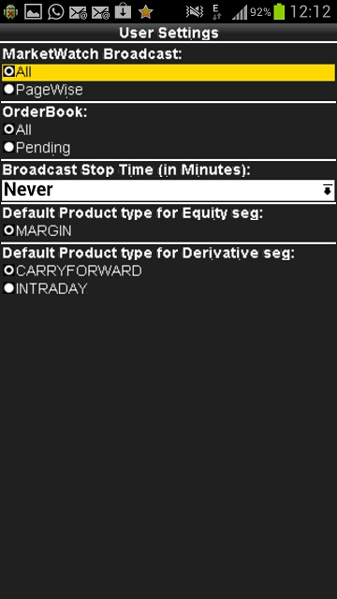

And after that save the setting .
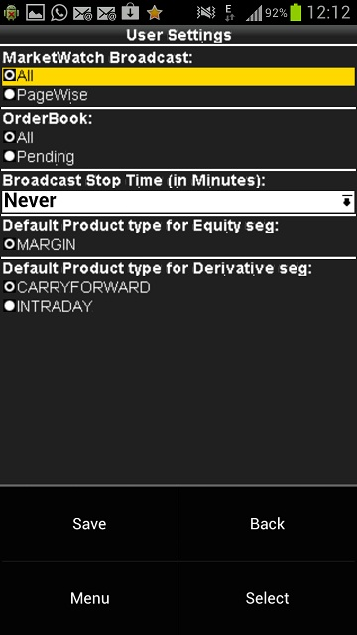

Thank you happy trading.........

