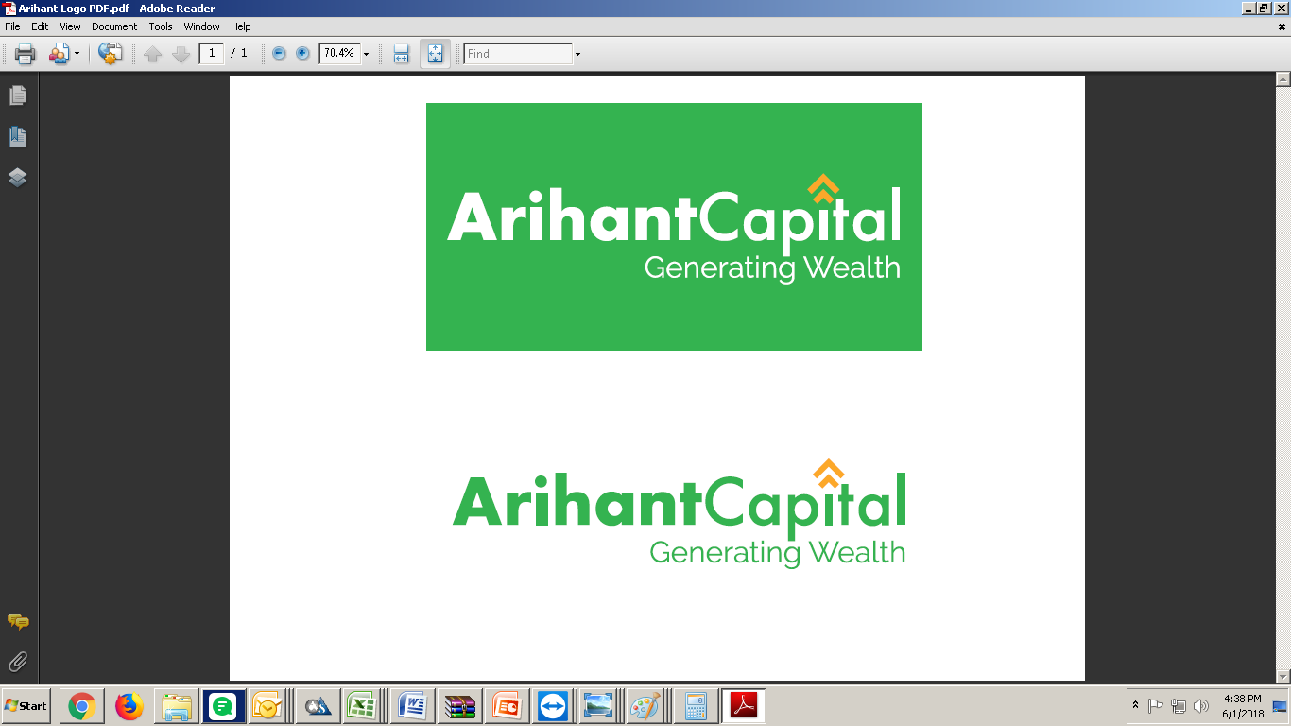

Functionality

Of

TechnicalTrade



**1 Introduction**

Technical Trader strategy has been envisaged to help traders to create and track positions on basis of technical conditions, without having to keep track of the same manually looking at charts. Orders are be generated automatically on satisfaction of the technical conditions.

* 1. Highlights

➢ Facility to create highly parameterized and customizable transaction pages

➢ Online Alerts Messages for client activities

➢ Utilizes highest levels of encryption standards

➢ Ease of Trading

➢ User-friendly work environment

1.2 Trading Features

➢ View the real-time based Market Information

➢ Receive on-line trade confirmations

➢ View Order and trade status

➢ View transaction history

➢ Use configurable information price tickers

➢ Provide on-line alerts for client activity



1. Technical Scan
   1. Formula Builder

Formula Builder allows to create formulae based on Technical Indicators.

You can select the indicator of your choice and input parameters. Using these parameters, the software created simple to complex formula as per conditions selected

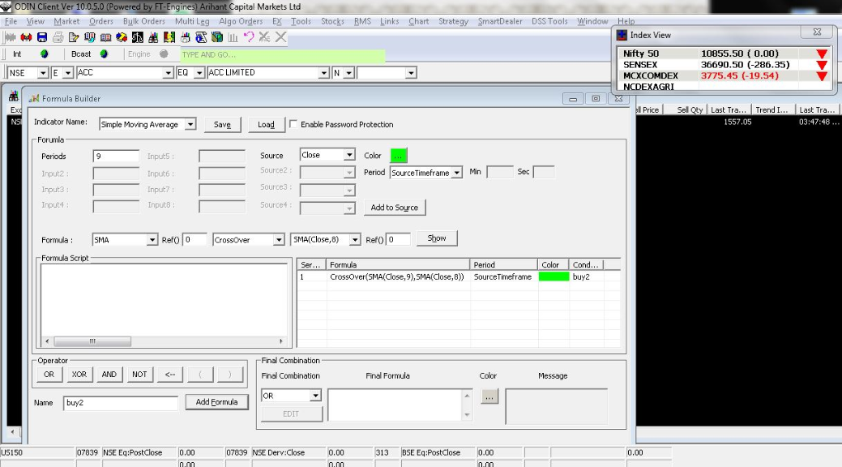

✓ In Indicator Name, select the required indicator Name the drop-down list option.

✓ Enter Periods.

✓ Select Source.

✓ Select Period. (If intraday option is selected then enter value in Min Text box).

✓ Select the required color from the Color box.

✓ To create condition, select combination from drop-down lists and references provided

✓ Click Show, to display selected condition in condition script box.

✓ In Condition Script box, you can add multiple conditions using “AND, OR,

XOR,NOT” operators.

✓ Enter condition name in Name box.

✓ Select Timeframe and color.



✓ Click Add condition, to add condition in the condition grid.

✓ Click Save, to save the formula template.

✓ You can create final combinations to create complex formula.

✓ Enter File Name and click Save.

✓ Click Load. The Open Window is displayed.

✓ Select required file of already saved formula template from the Open dialog

box and click Open to load existing formula.

2.2 Formula Live Scan

Formula Live Scan window displays the alerts generated using Formula. The Alerts are updated online. The values can be saved in excel. You can view chart from live scan window through the right-click option available.

Click Chart > Technical Scan > Formula Live Scan > Select Portfolio to Scan > Select Formula > Click Run. (Formula Live scan window will open and update online with satisfied conditions). The Formula Live Scan window is displayed and updated online with satisfied conditions.

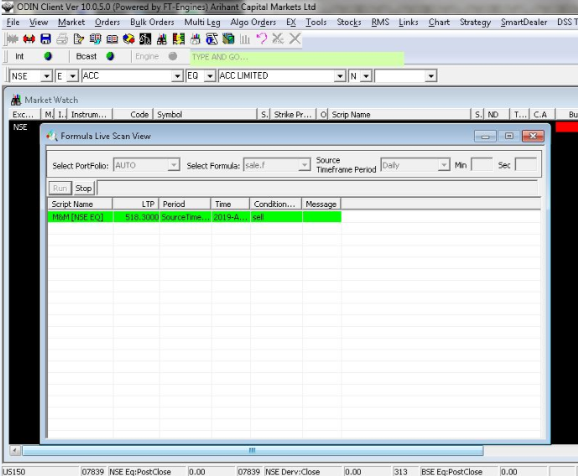

Click Stop, to stop the process.

Right-click inside the live window to view more options

(Such as View Graph, Save to Excel, beep on Alerts etc.).



1. Strategy Menus

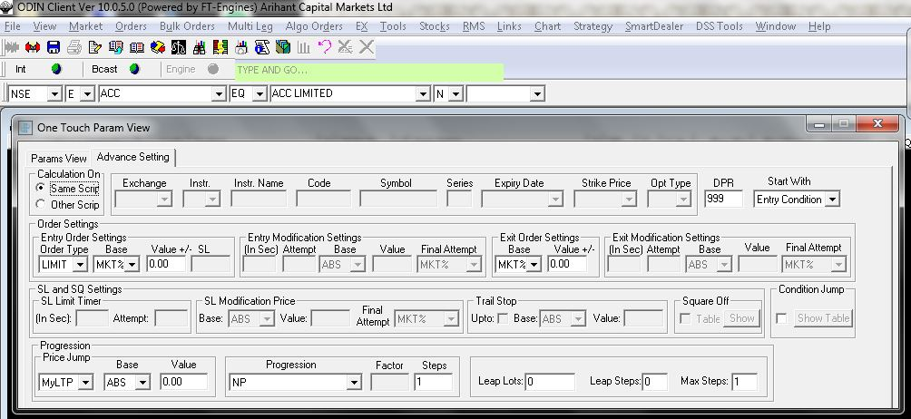

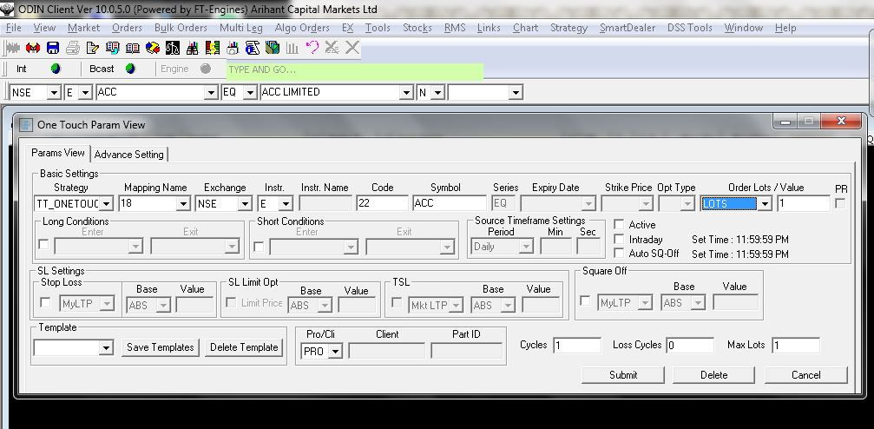



* 1. Param View

1. Select Strategy, set mapping name & Select Scrip
2. Select Long & Short Conditions created buy formula builder
3. Set source time frame, we can select status of strategy & timing for auto square off & Intraday of short order.
4. SL Setting is given to define normal Stop Loss order as well as Trailing stop loss SL Limit order
5. Pro/ Clip: This will allow whether strategy has been created in pro or client account.
   1. Advance Setting
6. Will decide whether entire calculation will occur on the selected scrip or on some other reference scrip.
7. Option to modify exit order in set time
8. Select parameters to generate order value for Long & Exit order both
9. Option to generate Final order as market or we can keep in pending status
10. Back test Report

This option allows user to back test strategy on tick data available in system, for the selected period. User will be able to see a summary report, along with detailed order/trade report. User can save this data in csv for further use.

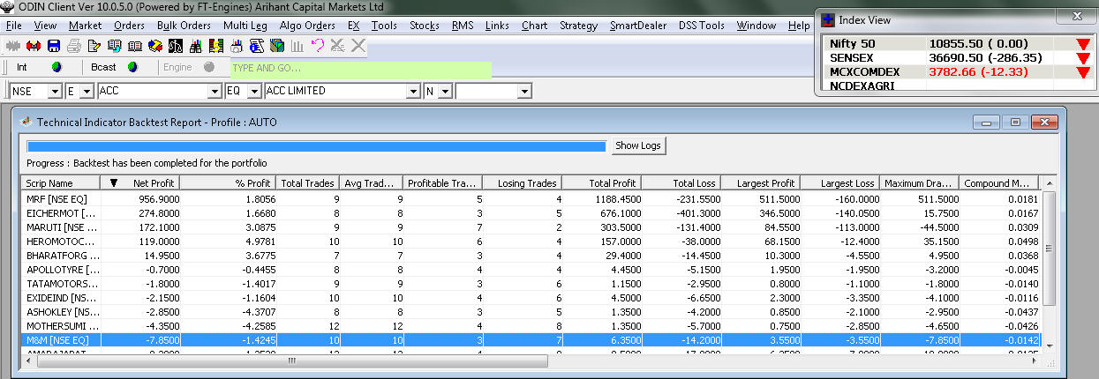



1. Tech Trader Watch Window.

Tech Trader Watch is your strategy/mapping activity dashboard, which allows you to monitor all the important items, and perform actions on selected/all mappings.

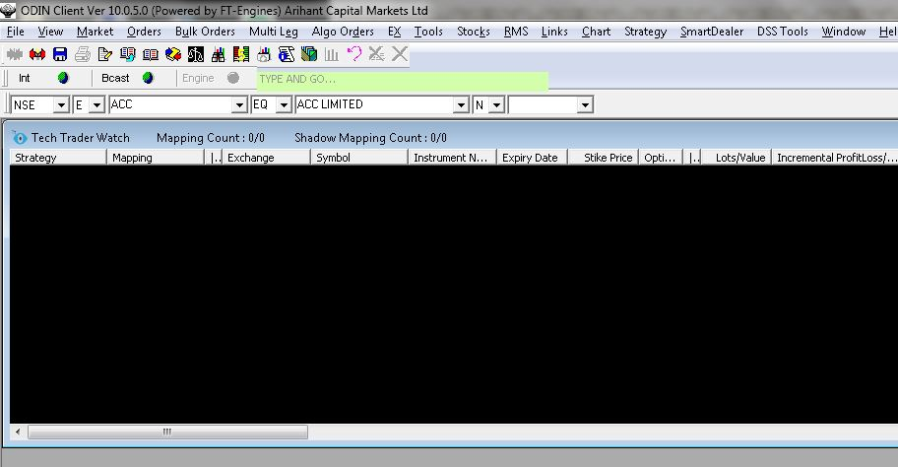

1. Dispatch Order Book.

After start strategy & start ATS option orders will be generated as per the strategy & reflect in Dispatch order book by accepting this order we can send to exchange.

